ARCHERYTAG TOURNAMENT REGISTRATION FORM
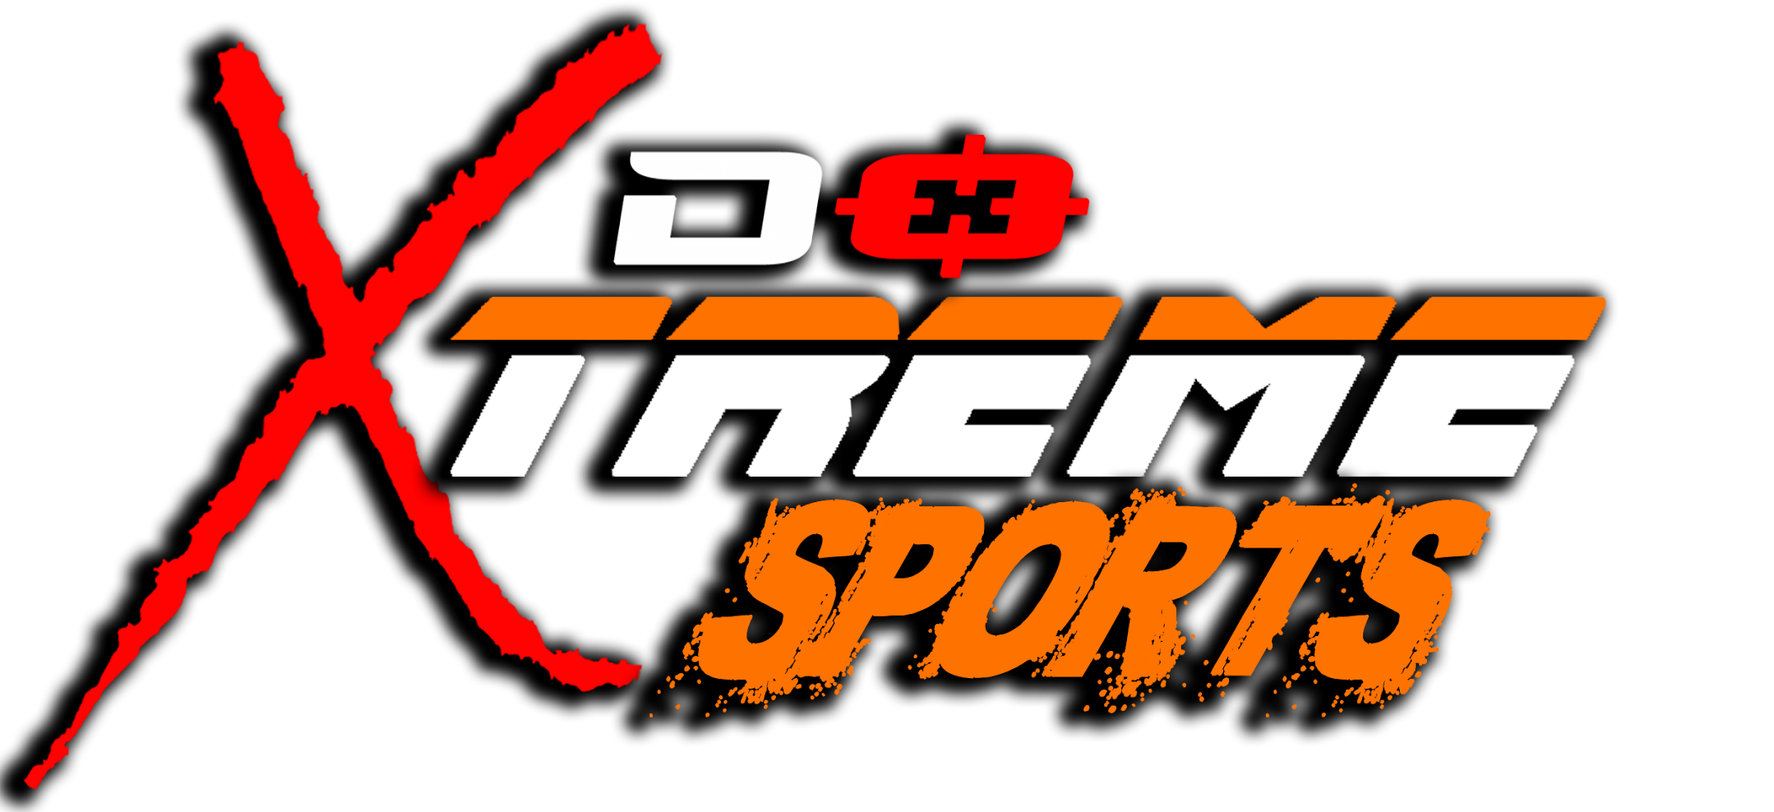

Indemnity Form
All players operated by Do Xtreme Sports Pte Ltd must sign and agree to the terms and conditions as stated in this Indemnity & Release form before commencing any sports activity.
I, the undersigned, with my details provided below, agree and understand the following Terms & Conditions as stated by Do Xtreme Sports Pte Ltd, before commencing the sport;-
- I agree to discontinue playing immediately upon the feeling of any unease, disoriented, or experiencing any lack of well-being or due to any medical reasons that arise during the entire participation of the sport. I agree to abide by the instructions given by Do Xtreme Sports Pte Ltd’s personnel to discontinue playing should they cite my safety as an immediate concern with the relation to the sport.
- I am aware of the potential risks of injury, including, but not limited to, being shot by the foam tip arrow, dartTags, failing, tripping, bruises from improper wear of safety gear provided and/or other injuries that arise from the designated fast-paced sport of the given time and date.
- I agree that by my participation in the sport provided by Do Xtreme Sports Pte Ltd, I hereby assume all risks, dangers and all responsibility from any losses and/or damages, whether caused in whole or in part by the negligence or other conduct of the owners, staff, agents, umpire or by any other person.
- I agree to absolve and not hold responsible for Do Xtreme Sports Pte Ltd, as well as its managers, trainers, instructors, administration officers, coaches or any other person associated with Do Xtreme Sports Pte Ltd for any losses, injuries, mishaps, medical issues and/or any other consequences of my decision to participate in the sport, as per details mentioned above. I understand that no financial and/or legal claims can be made against Do Xtreme Sports Pte Ltd for the prior mentioned issues in point 5.
- I understand and agree to follow all safety rules, regulations & procedures and in the event that that such rules and procedures not followed by myself, or others, it could result in my injury or death.
- I understand and acknowledge that staffs of Do Xtreme Sports Pte Ltd, hold the right to stop the game and dismissal from the field without refund if any players are found violating any safety rules, regulations & procedures.
- I authorise the use of my photos, video, name, comment, game result, etc. for promotional purposes by Do Xtreme Sports Pte Ltd.
- I declare that I am 18 years old or above, or, that I am 14-18 years old and have sought my parent’s/guardian’s consent in my participation in paintball activities as signed by my parent/guardian in the attached form given.

Organization/ Instituition:

______________________________________________

Team name:

______________________________________________

Category: OPEN CATEGORY

Compulsory (5 Players)
Captain | Birth Date | Contact No. | Email

Player’s Name | Birth Date | Contact No.

Reserve (2 Players)
Player’s Name | Birth Date | Contact No.

Payment via: IBanking Transfer / Paypal / Vendors.gov (Please circle one)

